A Mini Project Report

On

**“HELP ME COOK”**

submitted in partial fulfilment of the requirements for the award of degree of

**Bachelor of Engineering**

In

**Computer Science and Engineering**

Submitted by

MD.SAFI UR RAHMAN KHAN 1608-17-733-062

Under the Guidance of

Mrs.K. SHALINI

Asst. Professor



**Department of Computer Science and Engineering**

**Matrusri Engineering College**

(Affiliated to Osmania University, Approved by AICTE)

Saidabad, Hyderabad - 500059

(2017-2018)

**Department of Computer Science and Engineering**

**Matrusri Engineering College**

(Affiliated to Osmania University, Approved by AICTE)

Saidabad, Hyderabad - 500059



CERTIFICATE

This is to Certify that A Mini Project report entitled **“HELP ME COOK**” is being submitted by MD. SAFI UR RAHMAN KHAN **(**1608-17-733-062**),** PRABHALA DATTA PARJANYA SAKETH **(**1608-17-733-063**),** P.VASU DEVA REDDY (1608-17-733-072) in partial fulfilment of the requirement of the award for the degree of Bachelor of Engineering in “Computer Science and Engineering” O.U., Hyderabad during the year 2017-2018 is a record of bonafide work carried out by him/her under my guidance. The results presented in this mini project report have been verified and are found to be satisfactory.

Project Guide HOD

**Mrs.K.Shalini Dr. P. Vijayapal Reddy**

**Assistant Professor Professor & Head**

**Dept. of CSE Dept. of CSE**

**External Examiner(s)**

**ACKNOWLEDGEMENT**

It is our privilege and pleasure to express our profound sense of respect, gratitude and indebtedness to our guide **Mrs.K.Shalini**, Assistant professor, Department of Computer Science and Engineering, Matrusri Engineering College, for his/her indefatigable inspiration, guidance, cogent discussion, constructive criticisms and encouragement throughout this dissertation work.

We express our sincere thanks to mini project coordinator **Mrs. K. Shalini**, Assistant professor, Department of Computer Science and Engineering, Matrusri Engineering College, for her valuable suggestions and constant help in completing the work.

We express our sincere gratitude to **Dr. P. Vijayapal Reddy**, Professor & Head, Department of Computer Science and Engineering, Matrusri Engineering College, for his precious suggestions, motivation and co-operation.

We extend our sincere thanks to **Dr. D. Hanumantha Rao**, Principal, Matrusri Engineering College, Saidabad, Hyderabad, for his encouragement and constant help.

We extend our sincere thanks to all the teaching and non-teaching staff of CSE Department for their support and encouragement.

Last but not least, we wish to acknowledge our friends and family members for giving moral strength and helping us to complete this dissertation.

**CONTENTS**

Abstract

List of Figures

**S.No. Chapter Pg No.**

**1 Introduction 7**

* 1. Existing System 7
  2. Disadvantages 7
  3. Proposed System 7
  4. Advantages 8
  5. Scope 9
  6. System Requirements 9
  7. Technology Used 10

1.7.1 JAVA 10

1.7.2 Android 11

1.7.3 File Handling in Android 12

**2 Architecture& Implementation 14**

2.1 Modules 14

* 1. Code 15

2.2.1 Java Code 15

2.2.2 XML Code 37

1. **Output Screenshots 48**
2. **Conclusion 53**
3. **Future Enhancement 53**
4. **References 53**

**ABSTRACT**

Women, for as long as we know now, face a common question every day. “What shall I/we cook today??” This simple question many times becomes an irritation to many and often leads to wastage of a lot of time.

This project aims to put an end to this common household question. We are aiming to create a mobile application which hopes to remove this dilemma by suggesting a food item every evening (or whenever required). The user has an option to select the suggested food item or he may also request for another one. The app maintains a favourite food items list and also keeps into account the currently available ingredients and suggests the user a food item accordingly. It also makes sure that the item suggested is not repeated at least within the same week.

By using this application it becomes very easy and takes a lot of pressure off women, especially who are working, as it gives them a full account of the items present in the house and even gives them a suggestion to cook.

**LIST OF FIGURES**

|  |  |  |
| --- | --- | --- |
| **Fig No.** | **Name of the Figure** | **Page No** |
| **1.1**  **1.2**  **1.3**  **1.4**  **1.5**  **1.6**  **1.7**  **1.8**  **1.9**  **1.10** | **MAIN SCREEN OF THE APP**  **SCREEN FOR ENTERING FOOD ITEMS**  **ENTERING A FOOD ITEM**  **DISPLAYING THE FOOD LIST**  **SCREEN FOR ENTERING THE INGREDIENTS**  **ENTERING THE INGREDIENTS**  **DISPLAING THE AVAILABLE INGREDIENTS**  **SUGGESTION OF FOOD ITEM**  **SUGGESTION OF NEW FOOD ITEM**  **IF SATISFIED BUTTON IS CLICKED** | **48**  **48**  **49**  **49**  **50**  **50**  **51**  **51**  **52**  **52** |

1. **INTRODUCTION**

**1.1 Existing System**

Many people struggle to decide what to cook. According to a survey conducted by us, nearly in 70% of the houses, it is the mother who has the responsibility of deciding what to cook.This often results in irritation and loss of lot of time.

Especially working women, who reach home tired, often feel this irritation taking a toll on their behavior and it results in fights and fussy eating habits.

Women also have a tough time in remembering the ingredients present in the house.

It is also often observed that every person in the house doesn’t like one or the other food item and complains about it when it is cooked. This results in fights between various family members on a petty issue such as food.

**1.2 Disadvantages**

Some of the major disadvantages of the current system are listed below:

* Fights between different members of the family.
* Irritation in the person who has to decide what to cook.
* Wastage of a lot of time, just for deciding what to cook.
* Often resulting in fussy eating habits.
* Working women do not have a lot of time to instruct the cook what to cook.
* No fool proof method of keeping track of the ingredients present in the house.

**1.3 Proposed System**

Our project aims to put an end to this common household problem. We are aiming to create a mobile application which hopes to remove this dilemma by suggesting a food item every evening (or whenever required). The user has an option to select the suggested food item or may also request for another one. The app also maintains a favorite food items list and the currently available ingredients. It suggests the user a food item by keeping in account the various food items the user can cook and the currently available ingredients.

The user has to store his favorite food list along with the primary and secondary ingredients required to cook that particular food item. For example, if the user wants to store “Palak Paneer” then the respective primary and secondary ingredients could be “Paneer” and “Palak” respectively.

The user then has to maintain a ingredients list along with the number of units of each ingredients present. Say for a family of five to cook “Palak Paneer”, one kg of Palak is required along with 200g of Paneer then, 1kg of Palak is considered as 1 unit. Similarly, 200 g of Paneer is considered as 1 unit. Whenever the user buys a new ingredient, he has to enter the name of the ingredient and the number of nits of that ingredient purchased.

Whenever the application suggests a new food item to cook, the user has a choice of selecting that food item or ask for another one. If the user is satisfied, with the suggested food item, then he/she selects “Satisfied” option. Then the app automatically modifies the ingredients list.

**1.4 Advantages**

Some of the advantages of the suggested method are:

* Fool proof method of deciding what to cook.
* Less time spent in deciding what to cook.
* No scope of irritation in deciding the meal to be cooked.
* A systematic maintenance of the currently available ingredients.
* An ordered list of the favorite food items list.
* Less scope of fussy eating habits.
* Working women now can easily suggest the cook what to cook by just taking suggestion from the app.

**1.5 Scope**

* It can be used extensively by women who have the responsibility to decide and cook.
* This app can be used by anyone who knows how to operate an android phone.
* This app aims to save a lot of time and reduce unnecessary troubles.

**1.6 System Requirements**

HARDWARE REQUIREMENTS

FOR DEVELOPMENT:

* Intel Core i3 or above.
* Minimum 4GB RAM.

FOR IMPLEMENTATION:

* Android Virtual device(AVD) (OR)
* Working Android Phone with min 1 GB RAM.

SOFTWARE REQUIREMENTS

FOR DEVELOPMENT:

* Windows 7 or above.
* Java SE 8 or above.
* Android Studio 2 or above.

FOR IMPLEMENTATION:

* Android 4.1 or above

**1.7 Technology Used**

**1.7.1 JAVA**

JAVA was developed by Sun Microsystems Inc in 1991, later acquired by Oracle Corporation. It was developed by James Gosling and Patrick Naughton. It is a simple programming language.  Writing, compiling and debugging a program is easy in java.  It helps to create modular programs and reusable code.

Java Virtual Machine (JVM)  
This is generally referred as JVM. Before, we discuss about JVM lets see the phases of program execution. Phases are as follows: we write the program, then we compile the program and at last we run the program.  
1) Writing of the program is of course done by java programmer like you and me.  
2) Compilation of program is done by javac compiler, javac is the primary java compiler included in java development kit (JDK). It takes java program as input and generates java byte code as output.  
3) In third phase, JVM executes the byte code generated by compiler. This is called program run phase.

So, now that we understood that the primary function of JVM is to execute the byte code produced by compiler. Each operating system has different JVM, however the output they produce after execution of byte code is same across all operating systems. That is why we call java as platform independent language.

**Java Buzzwords**

1. Simple
2. Object-Oriented
3. Portable
4. Platform independent
5. Secured
6. Robust
7. Architecture neutral
8. Interpreted
9. High Performance
10. Multithreaded
11. Distributed
12. Dynamic

**Object Oriented Programming Features of Java**

Object oriented programming is a way of organizing programs as collection of objects, each of which represents an instance of a class.

4 main concepts of Object Oriented programming are:

1. Abstraction
2. Encapsulation
3. Inheritance
4. Polymorphism

**1.7.2 Android**

Android is a Linux based operating system it is designed primarily for touch screen mobile devices such as smart phones and tablet computers. The operating system have developed a lot in last 15 years starting from black and white phones to recent smart phones or mini computers. One of the most widely used mobile OS   these days is android.  The android is software that was founded in Palo Alto of California in 2003.

The android is a powerful operating system and it supports large number of applications in Smartphones. These applications are more comfortable and advanced for the users. The hardware that supports android software is based on ARM architecture platform. The android is an open source operating system means that it’s free and any one can use it. The android has got millions of apps available that can help you managing your life one or other way and it is available low cost in market at that reasons android is very popular.

The android development supports with the full java programming language. Even other packages that are API and JSE are not supported. The first version 1.0 of android development kit (SDK) was released in 2008 and latest updated version is jelly bean.

**Android Architecture**

The android is a operating system and is a stack of software components which is divided into five sections and four main layers that is

* Linux Kernel
* Libraries
* Android Runtime
* Application frame Work
* Applications and Features

**Linux Kernel:**

The android uses the powerful Linux kernel and it supports wide range of hardware drivers. The kernel is the heart of the operating system that manages input and output requests from software. This provides basic system functionalities like process management, memory management, device management like camera, keypad, display etc the kernel handles all the things. The Linux is really good at networking and it is not necessary to interface it to the peripheral hardware. The kernel itself does not interact directly with the user but rather interacts with the shell and other programs as well as with the hard ware devices on the system.

**Libraries:**

The on top of a Linux kennel there is a set of libraries including open source web browser such as webkit, library libc. These libraries are used to play and record audio and video. The SQLite is a data base which is useful for storage and sharing of application data. The SSL libraries are responsible for internet security etc.

**Android Runtime:**

The android runtime provides a key component called Dalvik Virtual Machine which is a kind of java virtual machine. It is specially designed and optimized for android. The Dalvik VM is the process virtual machine in the android operating system. It is a software that runs apps on android devices.

The Dalvik VM makes use of Linux core features like memory management and multithreading which is in a java language. The Dalvik VM enables every android application to run it own process. The Dalvik VM  executes the files in the .dex format.

**Application Framework:**

You will find all the android applications at the top layer and you will write your application and install on this layer. Example of such applications are contacts, books, browsers, services etc. Each application perform a different role in the over all applications.

**1.7.3 File Handling in Android**

Android provides many kinds of storage for applications to store their data. These storage places are shared preferences, internal and external storage, SQLite storage, and storage via network connection.

In this chapter we are going to look at the internal storage. Internal storage is the storage of the private data on the device memory.

By default these files are private and are accessed by only your application and get deleted , when user delete your application.

Writing file

In order to use internal storage to write some data in the file, call the openFileOutput() method with the name of the file and the mode. The mode could be private, public e.t.c. Its syntax is given below −

FileOutputStream fOut = openFileOutput("file name here",MODE_WORLD_READABLE);

The method openFileOutput() returns an instance of FileOutputStream. So you receive it in the object of FileInputStream. After that you can call write method to write data on the file. Its syntax is given below –

String str = "data";

fOut.write(str.getBytes());

fOut.close();

Reading file

In order to read from the file you just created , call the openFileInput() method with the name of the file. It returns an instance of FileInputStream. Its syntax is given below –

FileInputStream fin = openFileInput(file);

After that, you can call read method to read one character at a time from the file and then you can print it. Its syntax is given below –

int c;

String temp="";

while( (c = fin.read()) != -1){

temp = temp + Character.toString((char)c);

}

//string temp contains all the data of the file.

fin.close();

1. **ARCHITECTURE AND IMPLEMENTATION**

**2.1 Modules**

1. **Main Activity:** This is the main opening screen of the application. It is responsible for switching between various other activities. It basically has three buttons “Entering Food List”, which is used to switch to the activity where the user enters food items, “Entering Ingredients List”, which is used to switch to the activity where the user enters the ingredients available, “Help me Cook”, which is used to generate the food item to be cooked.
2. **Entering Food List:** This activity is activated when the user clicks the “Entering Food List” button in the Main Activity. Here the user is asked to enter the food items he/she can cook along with the primary ingredients and secondary ingredients. There are majorly three buttons here. “Save”, which is used to save the entered information into the file, “Delete” , which is used to delete all the information saved in the file, “Display”, which is used to display all the information present in the file.
3. **Entering Ingredients List:** This activity is activated when the user clicks the “Entering Ingredients list” button in the Main Activity. Here the user is asked to enter the ingredients present in the house along with their count. There are majorly three buttons here. “Save”, which is used to save the entered information into the file, “Delete” , which is used to delete all the information saved in the file, “Display”, which is used to display all the information present in the file.
4. **Help me Cook:** This is the most important module in the project. This activity is activated when the user clicks the Help me Cook button in the Main Activity. Here the suggested food item is displayed along with two buttons. “Satisfied, which is clicked when the user is satisfied with the suggested food item then the application will modify the ingredients list appropriately, “Nope!! Want a new One” , which is clicked when the user is not satisfied with the suggested food item and wants to request for a new one.

**2.2 Code**

**2.2.1 Java Code**

**MainActivity.java**

|  |
| --- |
| Package com.example.helpmecook;  import android.content.Intent; |
| import android.support.v7.app.AppCompatActivity; |  |
| import android.os.Bundle; |  |
| import android.view.View; |  |
| import android.widget.Button; |  |
|  |  |
| public class MainActivity extends AppCompatActivity { |  |
|  |  |
| Button foodlist,ingredlist,generating; |  |
| @Override |  |
| protected void onCreate(final Bundle savedInstanceState) { |  |
| super.onCreate(savedInstanceState); |  |
| setContentView(R.layout.activity_main); |  |
|  |  |
| //initializing the buttons with their respective id present in layout |  |
| foodlist=findViewById(R.id.foodlistb); |  |
| ingredlist=findViewById(R.id.ingredlistb); |  |
| generating=findViewById(R.id.generateb); |  |
|  |  |
| //assigning event listeners to each button |  |
|  |  |
| foodlist.setOnClickListener(new View.OnClickListener() { |  |
| @Override |  |
| public void onClick(View view) { |  |
| //calling the activity that contains the code for entering a food item into the |  |
| //file |  |
| Intent intent = new Intent( MainActivity.this, foodlist.class); |  |
| startActivity(intent); |  |
| } |  |
| }); |  |
|  |  |
| ingredlist.setOnClickListener(new View.OnClickListener() { |  |
| @Override |  |
| public void onClick(View view) { |  |
| //calling the activity that contains the code for entering an ingredient |  |
| //into the file |  |
| Intent intent1 = new Intent(MainActivity.this , ingredlist.class); |  |
| startActivity(intent1); |  |
| } |  |
| }); |  |
|  |  |
| generating.setOnClickListener(new View.OnClickListener() { |  |
| @Override |  |
| public void onClick(View view) { |  |
| //calling the activity that contains the code for generating the food |  |
| //item and displaying onto the screen |  |
| Intent intent2 = new Intent(MainActivity.this , generatefood.class); |  |
| startActivity(intent2); |  |
|  |  |
| } |  |
| }); |  |
|  |  |
|  |  |
|  |  |
| } |  |
| } |  |
|  |  |
|  |  |

# displayfood.java

|  |
| --- |
| package com.example.helpmecook; |
|  |  |
|  |  |
|  |  |
|  |  |
|  |  |
|  |  |
|  |  |
|  |  |
|  |  |
|  |  |
|  |  |
|  |  |
|  |  |
|  |  |
|  |  |
|  |  |
|  |  |
|  |  |
|  |  |
|  |  |
|  |  |
|  |  |
|  |  |
|  |  |
|  |  |
|  |  |
|  |  |
|  |  |
|  |  |
|  |  |
|  |  |
|  |  |
|  |  |
|  |  |
|  |  |
|  |  |
|  |  |
|  |  |
|  |  |
|  |  |
|  |  |
|  |  |
|  |  |
|  |  |
|  |  |
|  |  |
|  |  |
|  |  |
|  |  |
|  |  |
|  |  |
|  |  |
|  |  |
|  |  |
|  |  |
|  |  |
|  |  |
|  |  |
|  |  |
|  |  |
|  |  |
|  |  |
| import android.content.Intent; | |
| import android.support.v7.app.AppCompatActivity; | |
| import android.os.Bundle; | |
| import android.view.View; | |
| import android.widget.Button; | |
| import android.widget.TextView; | |
|  | |
| import org.w3c.dom.Text; | |
|  | |
| import java.io.BufferedReader; | |
| import java.io.File; | |
| import java.io.FileInputStream; | |
| import java.io.FileNotFoundException; | |
| import java.io.IOException; | |
| import java.io.InputStreamReader; | |
| import java.util.LinkedList; | |
| import java.util.StringTokenizer; | |
|  | |
| public class displayfood extends AppCompatActivity { | |
| TextView displayfood; | |
| Button backb; | |
| private static String filename = "FoodList.txt"; | |
|  | |
| @Override | |
| protected void onCreate(Bundle savedInstanceState) { | |
| super.onCreate(savedInstanceState); | |
| setContentView(R.layout.activity_displayfood); | |
|  | |
| displayfood=findViewById(R.id.disp); | |
| backb=findViewById(R.id.button4); | |
| LinkedList<String> llfood = new LinkedList<String>(); | |
| File file=null; | |
| BufferedReader br= null; | |
| String sfinal=""; | |
| file=new File(getFilesDir(),filename); | |
| try { | |
| br= new BufferedReader(new InputStreamReader(new FileInputStream(file))); | |
| String strtemp; | |
| while((strtemp=br.readLine())!= null) | |
| { | |
| llfood.add(strtemp); | |
| } | |
|  | |
| for(String str : llfood) | |
| { | |
| StringTokenizer str1 = new StringTokenizer(str,","); | |
| sfinal = sfinal+str1.nextToken()+" (which require "+str1.nextToken()+" and "+str1.nextToken()+")\n"; | |
| } | |
| displayfood.setText(sfinal); | |
| br.close(); | |
| } catch (FileNotFoundException e) { | |
| e.printStackTrace(); | |
| } catch (IOException e) { | |
| e.printStackTrace(); | |
| } | |
|  | |
| backb.setOnClickListener(new View.OnClickListener() { | |
| @Override | |
| public void onClick(View view) { | |
| Intent intent = new Intent(displayfood.this,MainActivity.class); | |
| startActivity(intent); | |
|  | |
|  | |
|  | |
|  | |
|  | |
|  | |
|  | |
|  | |
|  | |
|  | |
|  | |
|  | |
|  | |

}

});

}

}

**displayingred.java**

|  |
| --- |
| package com.example.helpmecook;  import android.content.Intent; |
| import android.support.v7.app.AppCompatActivity; |  |
| import android.os.Bundle; |  |
| import android.view.View; |  |
| import android.widget.Button; |  |
| import android.widget.TextView; |  |
|  |  |
| import java.io.BufferedReader; |  |
| import java.io.File; |  |
| import java.io.FileInputStream; |  |
| import java.io.FileNotFoundException; |  |
| import java.io.IOException; |  |
| import java.io.InputStreamReader; |  |
| import java.nio.Buffer; |  |
| import java.util.LinkedList; |  |
|  |  |
| public class displayingred extends AppCompatActivity { |  |
|  |  |
| Button backb; |  |
| TextView displab; |  |
| private static String filename ="IngredList.txt"; |  |
|  |  |
| @Override |  |
| protected void onCreate(Bundle savedInstanceState) { |  |
| super.onCreate(savedInstanceState); |  |
| setContentView(R.layout.activity_displayingred); |  |
|  |  |
| backb=findViewById(R.id.button6); |  |
| displab=findViewById(R.id.textView5); |  |
| File file=null; |  |
| BufferedReader br=null; |  |
| file =new File(getFilesDir(),filename); |  |
| LinkedList<String> llingred = new LinkedList<String>(); |  |
| String sfinal=""; |  |
| try |  |
| { |  |
| br= new BufferedReader(new InputStreamReader(new FileInputStream(file))); |  |
| String strtemp; |  |
|  |  |
| while((strtemp = br.readLine())!=null) |  |
| { |  |
| llingred.add(strtemp); |  |
| } |  |
|  |  |
| //String sfinal=""; |  |
| for(String str : llingred) |  |
| { |  |
| sfinal = sfinal+str+"\n"; |  |
| } |  |
|  |  |
| displab.setText(sfinal); |  |
| br.close(); |  |
|  |  |
|  |  |
| } catch (FileNotFoundException e) { |  |
| e.printStackTrace(); |  |
| } catch (IOException e) { |  |
| e.printStackTrace(); |  |
| } |  |
|  |  |
| backb.setOnClickListener(new View.OnClickListener() { |  |
| @Override |  |
| public void onClick(View view) { |  |
| Intent intent = new Intent(displayingred.this,ingredlist.class); |  |
| startActivity(intent); |  |
| } |  |
| }); |  |
| } |  |

**Foodlist.java**

|  |
| --- |
| package com.example.helpmecook;  import android.content.Context; |
| import android.content.Intent; |  |
| import android.support.v7.app.AppCompatActivity; |  |
| import android.os.Bundle; |  |
| import android.view.View; |  |
| import android.widget.Button; |  |
| import android.widget.EditText; |  |
| import android.widget.Toast; |  |
|  |  |
| import java.io.File; |  |
| import java.io.FileOutputStream; |  |
| import java.io.IOException; |  |
|  |  |
| public class foodlist extends AppCompatActivity { |  |
|  |  |
| Button enterbutton , backbutton, deleteb, displayb; |  |
| EditText foodtext , primtext , sectext; |  |
| String sfood , sprimingred , ssecingred , sfinal; |  |
| private String filename="FoodList.txt"; |  |
| @Override |  |
| protected void onCreate(Bundle savedInstanceState) { |  |
| super.onCreate(savedInstanceState); |  |
| setContentView(R.layout.activity_foodlist); |  |
|  |  |
| //initializing the widgets with their id from layout |  |
| enterbutton = findViewById(R.id.enter); |  |
| backbutton = findViewById(R.id.back); |  |
| foodtext = findViewById(R.id.fooditem); |  |
| primtext = findViewById(R.id.pimingred); |  |
| sectext = findViewById(R.id.secingred); |  |
| deleteb = findViewById(R.id.button); |  |
| displayb=findViewById(R.id.button3); |  |
|  |  |
| //setting button event listeners |  |
|  |  |
| enterbutton.setOnClickListener(new View.OnClickListener() { |  |
| @Override |  |
| public void onClick(View view) { |  |
| sfood = foodtext.getText().toString(); |  |
| sprimingred = primtext.getText().toString(); |  |
| ssecingred = sectext.getText().toString(); |  |
| sfinal = sfood + "," + sprimingred + "," + ssecingred ; |  |
| //Initializing out to access the file |  |
| FileOutputStream out=null; |  |
| try { |  |
| //opening the file in append mode. the file is saved in internal storage |  |
| out=openFileOutput(filename, Context.MODE_APPEND); |  |
| out.write(sfinal.getBytes()); |  |
| out.write("\n".getBytes()); |  |
| out.close(); |  |
| Toast.makeText(foodlist.this,"Saved Successfully",Toast.LENGTH_SHORT).show(); |  |
| Intent intent = new Intent(foodlist.this , MainActivity.class); |  |
| startActivity(intent); |  |
|  |  |
|  |  |
| } catch (Exception e) { |  |
| e.printStackTrace(); |  |
| Toast.makeText(foodlist.this,"Sorry. Please try after some time", Toast.LENGTH_LONG).show(); |  |
| Intent intent = new Intent(foodlist.this , MainActivity.class); |  |
| startActivity(intent); |  |
|  |  |
| } |  |
| } |  |
| }); |  |
|  |  |
| backbutton.setOnClickListener(new View.OnClickListener() { |  |
| @Override |  |
| public void onClick(View view) { |  |
| Intent intent = new Intent(foodlist.this , MainActivity.class); |  |
| startActivity(intent); |  |
| } |  |
| }); |  |
|  |  |
| deleteb.setOnClickListener(new View.OnClickListener() { |  |
| @Override |  |
| public void onClick(View view) { |  |
| File file=null; |  |
| try |  |
| { |  |
| file=new File(getFilesDir(),filename); |  |
| file.delete(); |  |
| Toast.makeText(foodlist.this,"Deleting successfully",Toast.LENGTH_SHORT).show(); |  |
| } |  |
| catch(Exception e) |  |
| { |  |
| Toast.makeText(foodlist.this,"Deleting error",Toast.LENGTH_SHORT).show(); |  |
| e.printStackTrace(); |  |
| } |  |
| } |  |
| }); |  |
|  |  |
| displayb.setOnClickListener(new View.OnClickListener() { |  |
| @Override |  |
| public void onClick(View view) { |  |
| Intent intent = new Intent(foodlist.this,displayfood.class); |  |
| startActivity(intent); |  |
| } |  |
| }); |  |
|  |  |
| } |  |
| } |  |
|  |  |
|  |  |

**generatefood.java**

|  |  |
| --- | --- |
|  |  |
|  |  |
|  |  |
|  |  |
|  |  |
|  |  |
|  |  |
|  |  |
|  |  |
|  |  |
|  |  |
|  |  |
|  |  |
|  |  |
|  |  |
|  |  |
|  |  |
|  |  |
|  |  |
|  |  |
|  |  |
|  |  |
|  |  |
|  |  |
|  |  |
|  |  |
|  |  |
|  |  |
|  |  |
|  |  |
|  |  |
|  |  |
|  |  |
|  |  |
|  |  |
|  |  |
|  |  |
|  |  |
|  |  |
|  |  |
|  |  |
|  |  |
|  |  |
|  |  |
|  |  |
|  |  |
|  |  |
|  |  |
|  |  |
|  |  |
|  |  |
|  |  |
|  |  |
|  |  |
|  |  |
|  |  |
|  |  |
|  |  |
|  |  |
|  |  |
|  |  |
|  |  |
|  |  |
|  |  |
|  |  |
|  |  |
|  |  |
|  |  |
|  |  |
|  |  |
|  |  |
|  |  |
|  |  |
|  |  |
|  |  |
|  |  |
|  |  |
|  |  |
|  |  |
|  |  |
|  |  |
|  |  |
|  |  |
|  |  |
|  |  |
|  |  |
|  |  |
|  |  |
|  |  |
|  |  |
|  |  |
|  |  |
|  |  |
|  |  |
|  |  |
|  |  |
|  |  |
|  |  |
|  |  |
|  |  |
|  |  |
|  |  |
|  |  |
|  |  |
|  |  |
|  |  |
|  |  |
|  |  |
|  |  |
|  |  |
|  |  |
|  |  |
|  |  |
|  |  |
|  |  |
|  |  |
|  |  |
|  |  |
|  |  |
|  |  |
|  |  |
|  |  |
|  |  |
|  |  |
|  |  |
|  |  |
|  |  |
|  |  |
|  |  |
|  |  |
|  |  |
|  |  |
|  |  |
|  |  |
|  |  |
|  |  |
|  |  |
|  |  |
|  |  |
|  |  |
|  |  |
|  |  |
|  |  |
|  |  |
|  |  |
|  |  |
|  |  |
|  |  |
|  |  |
|  |  |
|  |  |
|  |  |
|  |  |
|  |  |
|  |  |
|  |  |
|  |  |
|  |  |
|  |  |
|  |  |
|  |  |
|  |  |
|  |  |
|  |  |
|  |  |
|  |  |
|  |  |
|  |  |
|  |  |
|  |  |
|  |  |
|  |  |
|  |  |
|  |  |
|  |  |
|  |  |
|  |  |
|  |  |
|  |  |
|  |  |
|  |  |
|  |  |
|  |  |
|  |  |
|  |  |
|  |  |
|  |  |
|  |  |
|  |  |
|  |  |
|  |  |
|  |  |
|  |  |
|  |  |
|  |  |
|  |  |
|  |  |
|  |  |
|  |  |
|  |  |
|  |  |
|  |  |
|  |  |
|  |  |
|  |  |
|  |  |
|  |  |
|  |  |
|  |  |
|  |  |
|  |  |
|  |  |
|  |  |
|  |  |
|  |  |
|  |  |
|  |  |
|  |  |
|  |  |
|  |  |
|  |  |
|  |  |
|  |  |
|  |  |
|  |  |
|  |  |
|  |  |
|  |  |
|  |  |
|  |  |
|  |  |
|  |  |
|  |  |
|  |  |
|  |  |
|  |  |
|  |  |
|  |  |
|  |  |
|  |  |
|  |  |
|  |  |
|  |  |
|  |  |
|  |  |
|  |  |
|  |  |
|  |  |
|  |  |
|  |  |
|  |  |
|  |  |
|  |  |
|  |  |
|  |  |
|  |  |
|  |  |
|  |  |
|  |  |
|  |  |
|  |  |
|  |  |
|  |  |
|  |  |
|  |  |
|  |  |
|  |  |
|  |  |
| package com.example.helpmecook;  import android.content.Context; |
| import android.content.Intent; |  |
| import android.support.v7.app.AppCompatActivity; |  |
| import android.os.Bundle; |  |
| import android.view.View; |  |
| import android.widget.Button; |  |
| import android.widget.TextView; |  |
| import android.widget.Toast; |  |
|  |  |
| import java.io.BufferedReader; |  |
| import java.io.File; |  |
| import java.io.FileInputStream; |  |
| import java.io.FileNotFoundException; |  |
| import java.io.FileOutputStream; |  |
| import java.io.IOException; |  |
| import java.io.InputStreamReader; |  |
| import java.util.LinkedList; |  |
| import java.util.Random; |  |
| import java.util.StringTokenizer; |  |
|  |  |
| public class generatefood extends AppCompatActivity { |  |
|  |  |
| Button satisfiedb , notsatisfiedb ; |  |
| TextView fooddisplay; |  |
| private final String filenameFood = "FoodList.txt"; |  |
| private final String filenameIngred = "IngredList.txt"; |  |
| LinkedList<String> lingred = new LinkedList<String>(); |  |
| LinkedList<String> lfood = new LinkedList<String>(); |  |
|  |  |
| int countForPrim; //counter for primary ingredient |  |
| int countForSec; //counter for secondary ingredient |  |
| @Override |  |
| protected void onCreate(Bundle savedInstanceState) { |  |
| super.onCreate(savedInstanceState); |  |
| setContentView(R.layout.activity_generatefood); |  |
|  |  |
| //initializing the widgets by their id in layout |  |
| satisfiedb = findViewById(R.id.satis); |  |
| notsatisfiedb = findViewById(R.id.nop); |  |
| fooddisplay =findViewById(R.id.printfood); |  |
|  |  |
| File file1 = null; |  |
| File file2 = null; |  |
| BufferedReader bfood = null; |  |
| BufferedReader bingred = null; |  |
| //int finalPresent = 0; //set this only when the item is to be selected finally |  |
| file1 = new File(getFilesDir(), filenameFood); |  |
| file2 = new File(getFilesDir(), filenameIngred); |  |
|  |  |
| try { |  |
|  |  |
| bfood = new BufferedReader(new InputStreamReader(new FileInputStream(file1))); |  |
| //FIRST WE WILL READ THE ENTIRE FOOD ITEMS FILE INTO A LINKED LIST |  |
| String sfoodtemp; |  |
| while ((sfoodtemp = bfood.readLine()) != null) { |  |
| lfood.add(sfoodtemp); |  |
| } |  |
| /*for(String str :lfood) |  |
| fooddisplay.setText( str);*/ |  |
|  |  |
| bingred = new BufferedReader(new InputStreamReader(new FileInputStream(file2))); |  |
| //NEXT WE WILL READ THE ENTIRE INGREDIENTS FILE INTO A LINKED LIST |  |
| String singredtemp; |  |
| while ((singredtemp = bingred.readLine()) != null) { |  |
| lingred.add(singredtemp); |  |
| } |  |
| bfood.close(); |  |
| bingred.close(); |  |
| } catch (FileNotFoundException e1) { |  |
| e1.printStackTrace(); |  |
| } catch (IOException e1) { |  |
| e1.printStackTrace(); |  |
| } |  |
| catch(Exception e) |  |
| { |  |
| Toast.makeText(generatefood.this, (CharSequence) e,Toast.LENGTH_SHORT).show(); |  |
| } |  |
|  |  |
| try{ |  |
| int mainCount = 0; |  |
| while (mainCount < 90) { |  |
| countForPrim=-1; |  |
| countForSec=-1; |  |
| // NOW WE GENERATE A RANDOM INTEGER TO CHOOSE FROM THE FOODS LIST HERE |  |
| Random rand = new Random(); |  |
| int randomValue = rand.nextInt(lfood.size()); |  |
| //Toast.makeText(generatefood.this,Integer.toString(randomValue),Toast.LENGTH_SHORT).show(); |  |
| //AFTER GENERATING A RANDOM INTEGER IN THE GIVEN RANGE, WE WILL STORE THE CORRESPONDING |  |
| //RECORD INTO VARIABLES |  |
| String chooseTemp = lfood.get(randomValue); |  |
| StringTokenizer str = new StringTokenizer(chooseTemp, ","); |  |
| String chooseFood = str.nextToken(); |  |
| String choosePrimaryIngred = str.nextToken(); |  |
| String chooseSecondaryIngred = str.nextToken(); |  |
|  |  |
| int flag = 0; //set this when primary ingredient is present |  |
|  |  |
| //NOW THE STRING IS SPLIT INTO RESPECTIVE COMPONENTS |  |
| //WE WILL NOW SPLIT THE INGREDIENTS FILE ITERATIVELY AND SEARCH IF THE PRIMARY INGREDIENT |  |
| //IS PRESENT OR NOT |  |
|  |  |
| for (int i = 0; i < lingred.size(); i++) { |  |
| String stringIngred = lingred.get(i); |  |
| //System.out.println(lingred.size()); |  |
| StringTokenizer str1 = new StringTokenizer(stringIngred, ","); |  |
| String ingredName = str1.nextToken(); |  |
| //int ingredCount = Integer.parseInt(str1.nextToken()); |  |
| countForPrim++; |  |
| if (choosePrimaryIngred.equals(ingredName)) { |  |
| flag = 1; |  |
| break; |  |
| } |  |
| } |  |
| if (flag == 0) //if primary ingredient is not present then continue |  |
| { |  |
| mainCount++; |  |
| continue; |  |
| } |  |
|  |  |
| //NOW AFTER SEARCHING FOR PRIMARY INGREDIENT IF THE PRIMARY INGREDIENT IS NOT PRESENT |  |
| //THEN WE HAVE TO GENERATE A RANDOM INTEGER AGAIN ELSE WE SEARCH FOR SECONDARY |  |
| //INGREDIENT |  |
|  |  |
|  |  |
| int finalPresent=0; |  |
| if (flag == 1) { |  |
| for (int i = 0; i < lingred.size(); i++) { |  |
| //SEARCHING FOR SECONDARY INGREDIENT |  |
| String stringIngred = lingred.get(i); |  |
| StringTokenizer str2 = new StringTokenizer(stringIngred, ","); |  |
| String ingredName = str2.nextToken(); |  |
| //int ingredCount = Integer.parseInt(str1.nextToken()); |  |
| countForSec++; |  |
| if (chooseSecondaryIngred.equals(ingredName)) { |  |
| finalPresent = 1; |  |
| break; |  |
| } |  |
| } |  |
| } |  |
|  |  |
| if (finalPresent == 0) //if the secondary ingredient is not present then continue |  |
| { |  |
| mainCount++; |  |
| continue; |  |
| } |  |
|  |  |
| if (finalPresent == 1) { |  |
| fooddisplay.setText(chooseFood); |  |
| //int choice = sc.nextInt(); |  |
| break; |  |
|  |  |
| } |  |
|  |  |
| } |  |
|  |  |
| if(mainCount==90) |  |
| { |  |
| Toast.makeText(generatefood.this,"Sorry nothing from your available ingredients can be cooked ",Toast.LENGTH_LONG).show(); |  |
| Intent intent = new Intent(generatefood.this,MainActivity.class); |  |
| startActivity(intent); |  |
|  |  |
| } |  |
| } |  |
|  |  |
| catch (NumberFormatException e) |  |
| { |  |
| Toast.makeText(generatefood.this,"Sorry try after sometime(number format)",Toast.LENGTH_SHORT).show(); |  |
| } |  |
| catch(ArrayIndexOutOfBoundsException e) |  |
| { |  |
| Toast.makeText(generatefood.this,"Sorry try after sometime(array out of bounds)",Toast.LENGTH_SHORT).show(); |  |
| } |  |
| catch (ArrayStoreException e) |  |
| { |  |
| Toast.makeText(generatefood.this,"Sorry try after sometime(array store)",Toast.LENGTH_SHORT).show(); |  |
| } |  |
| catch (IndexOutOfBoundsException e) |  |
| { |  |
| Toast.makeText(generatefood.this,"Sorry try after sometime(index of bounds)",Toast.LENGTH_SHORT).show(); |  |
| } |  |
| catch(Exception e) |  |
| { |  |
| Toast.makeText(generatefood.this, (CharSequence) e,Toast.LENGTH_SHORT).show(); |  |
| e.printStackTrace(); |  |
| } |  |
|  |  |
|  |  |
| //assigning the event listeners |  |
| satisfiedb.setOnClickListener(new View.OnClickListener() { |  |
| @Override |  |
| public void onClick(View view) { |  |
|  |  |
|  |  |
| try { |  |
| String strttemp = lingred.get(countForPrim); |  |
| StringTokenizer strr1 = new StringTokenizer(strttemp, ","); |  |
| String ingredName1 = strr1.nextToken(); |  |
| String strtemp11 = strr1.nextToken(); |  |
| int ingredCount = Integer.parseInt(strtemp11); |  |
| ingredCount--; |  |
| if (ingredCount == 0) { |  |
| lingred.remove(countForPrim); |  |
| if (countForPrim < countForSec) |  |
| countForSec--; |  |
| } else { |  |
| String ingredCount1 = Integer.toString(ingredCount); |  |
| String sfinal = ingredName1 + "," + ingredCount1; |  |
| lingred.remove(countForPrim); |  |
| lingred.add(countForPrim, sfinal); |  |
| } |  |
|  |  |
| String strtemp = lingred.get(countForSec); |  |
| StringTokenizer strr2 = new StringTokenizer(strtemp, ","); |  |
| String ingredName = strr2.nextToken(); |  |
| String strrtemp = strr2.nextToken(); |  |
| int ingredCount2 = Integer.parseInt(strrtemp); |  |
| ingredCount2--; |  |
| if (ingredCount2 == 0) { |  |
| lingred.remove(countForSec); |  |
|  |  |
| } else { |  |
| String ingredCount12 = Integer.toString(ingredCount2); |  |
| String sfinal = ingredName + "," + ingredCount12 ; |  |
| lingred.remove(countForSec); |  |
| lingred.add(countForSec, sfinal); |  |
| } |  |
|  |  |
|  |  |
| FileOutputStream fis = null; |  |
|  |  |
| fis = openFileOutput(filenameIngred, Context.MODE_PRIVATE); |  |
| for (String strr : lingred) { |  |
| fis.write(strr.getBytes()); |  |
| fis.write("\n".getBytes()); |  |
|  |  |
| } |  |
| fis.close(); |  |
|  |  |
| /*catch (Exception e) { |  |
| e.printStackTrace(); |  |
| Toast.makeText(generatefood.this, "Updation error", Toast.LENGTH_SHORT).show(); |  |
| }*/ |  |
|  |  |
| Toast.makeText(generatefood.this, "updated successfully", Toast.LENGTH_SHORT).show(); |  |
| Intent intent = new Intent(generatefood.this, MainActivity.class); |  |
| startActivity(intent); |  |
| } |  |
| catch (Exception e) |  |
| { |  |
| Toast.makeText(generatefood.this, (CharSequence) e,Toast.LENGTH_SHORT).show(); |  |
| } |  |
|  |  |
| } |  |
| }); |  |
|  |  |
| notsatisfiedb.setOnClickListener(new View.OnClickListener() { |  |
| @Override |  |
| public void onClick(View view) { |  |
| //if not satisfied call this activity again |  |
| Toast.makeText(generatefood.this, "New item displayed", Toast.LENGTH_SHORT).show(); |  |
| Intent intent = new Intent(generatefood.this , generatefood.class); |  |
| startActivity(intent); |  |
|  |  |
| } |  |
| }); |  |
|  |  |
|  |  |
| } |  |
| } |  |
|  |  |
|  |  |

Ingredlist.java

package com.example.helpmecook;

|  |
| --- |
| import android.content.Context; |
| import android.content.Intent; |  |
| import android.support.v7.app.AppCompatActivity; |  |
| import android.os.Bundle; |  |
| import android.view.View; |  |
| import android.widget.Button; |  |
| import android.widget.EditText; |  |
| import android.widget.Toast; |  |
|  |  |
| import java.io.BufferedReader; |  |
| import java.io.File; |  |
| import java.io.FileInputStream; |  |
| import java.io.FileNotFoundException; |  |
| import java.io.FileOutputStream; |  |
| import java.io.InputStreamReader; |  |
| import java.util.LinkedList; |  |
| import java.util.StringTokenizer; |  |
|  |  |
| public class ingredlist extends AppCompatActivity { |  |
|  |  |
| Button backb , enterb , deleteb,displayb; |  |
| EditText ingredn , unitsc; |  |
| String singred , sunits , sfinal; |  |
| private final String filename = "IngredList.txt"; |  |
| @Override |  |
| protected void onCreate(Bundle savedInstanceState) { |  |
| super.onCreate(savedInstanceState); |  |
| setContentView(R.layout.activity_ingredlist); |  |
|  |  |
| //initialising the widgets by their id in layout |  |
| enterb=findViewById(R.id.enterbutton); |  |
| backb=findViewById(R.id.backbutton); |  |
| ingredn=findViewById(R.id.ingredname); |  |
| unitsc=findViewById(R.id.unitscount); |  |
| deleteb=findViewById(R.id.button2); |  |
| displayb=findViewById(R.id.button5); |  |
|  |  |
|  |  |
| //assigning button listeners |  |
| enterb.setOnClickListener(new View.OnClickListener() { |  |
| @Override |  |
| public void onClick(View view) { |  |
| singred = ingredn.getText().toString(); |  |
| sunits = unitsc.getText().toString(); |  |
| int unitsCount = Integer.parseInt(sunits); |  |
| sfinal = singred + "," + sunits ; |  |
|  |  |
| FileOutputStream temp = null; |  |
| FileOutputStream out =null; |  |
| File file =null; |  |
| BufferedReader inpIngred = null; |  |
| try { |  |
| temp=openFileOutput(filename, Context.MODE_APPEND); |  |
| temp.close(); |  |
|  |  |
| //NOW WE ARE GOING TO READ THE INGREDIENTS FILE INTO A LIST AND CHECKING WHETHER |  |
| //THE ENTERED INGREDIENT IS PRESENT OR NOT. IF THE INGREDIENT IS ALREADY PRESENT |  |
| //THEN JUST INCREMENT IT. ELSE IF THE INGREDIENT IS NOT PRESENT THEN |  |
| //ADD THE INGREDIENT INTO THE FILE |  |
|  |  |
| LinkedList<String> lingred= new LinkedList<String>(); |  |
| file=new File(getFilesDir(),filename); |  |
| inpIngred=new BufferedReader(new InputStreamReader(new FileInputStream(file))); |  |
| String strtemp; |  |
| while((strtemp = inpIngred.readLine()) != null) |  |
| { |  |
| lingred.add(strtemp); |  |
| } |  |
| inpIngred.close(); |  |
| int flag=0; //set this flag if the element is found. |  |
| for(int i=0;i<lingred.size();i++) |  |
| { |  |
| strtemp=lingred.get(i); |  |
| StringTokenizer str =new StringTokenizer(strtemp,","); |  |
| String ingredName = str.nextToken(); |  |
| int ingredCount = Integer.parseInt(str.nextToken()); |  |
| if(ingredName.equals(singred)) |  |
| { |  |
| //IF THE INGREDIENT IS ALREADY PRESENT THEN SET THE FLAG AND |  |
| //JUST REMOVE THE PREVIOUS ELEMENT FROM THE LIST, INCREMENT THE COUNT |  |
| //AND THEN ADD THE STRING BACK INTO THE LIST AND FINALLY WRITE THE LIST BACK TO THE FILE |  |
| flag=1; |  |
| lingred.remove(i); |  |
| ingredCount+=unitsCount; |  |
| String ingredCounttemp = Integer.toString(ingredCount); |  |
| String sfinal1 = ingredName + "," +ingredCounttemp ; |  |
| lingred.add(i,sfinal1); |  |
| out=openFileOutput(filename,Context.MODE_PRIVATE); |  |
| for(int j=0;j<lingred.size();j++) |  |
| { |  |
| out.write((lingred.get(j)).getBytes()); |  |
| out.write("\n".getBytes()); |  |
| } |  |
| out.close(); |  |
| break; |  |
|  |  |
| } |  |
| } |  |
|  |  |
| FileOutputStream outfile = null; |  |
|  |  |
| if(flag==0) |  |
| { |  |
| outfile= openFileOutput(filename,Context.MODE_APPEND); |  |
| outfile.write(sfinal.getBytes()); |  |
| outfile.write("\n".getBytes()); |  |
| outfile.close(); |  |
| } |  |
| Toast.makeText(ingredlist.this,"Saved Successfully",Toast.LENGTH_SHORT).show(); |  |
| Intent intent=new Intent(ingredlist.this,MainActivity.class); |  |
| startActivity(intent); |  |
|  |  |
|  |  |
| } catch (Exception e) { |  |
| e.printStackTrace(); |  |
| Toast.makeText(ingredlist.this,"Sorry try after sometime",Toast.LENGTH_SHORT).show(); |  |
| Intent intent=new Intent(ingredlist.this,MainActivity.class); |  |
| startActivity(intent); |  |
| } |  |
|  |  |
|  |  |
|  |  |
| } |  |
| }); |  |
|  |  |
| backb.setOnClickListener(new View.OnClickListener() { |  |
| @Override |  |
| public void onClick(View view) { |  |
| Intent intent = new Intent(ingredlist.this , MainActivity.class); |  |
| startActivity(intent); |  |
| } |  |
| }); |  |
|  |  |
| deleteb.setOnClickListener(new View.OnClickListener() { |  |
| @Override |  |
| public void onClick(View view) { |  |
| File file=null; |  |
| file=new File(getFilesDir(),filename); |  |
| file.delete(); |  |
| Toast.makeText(ingredlist.this,"Deleted Successfully",Toast.LENGTH_SHORT).show(); |  |
| } |  |
| }); |  |
|  |  |
| displayb.setOnClickListener(new View.OnClickListener() { |  |
| @Override |  |
| public void onClick(View view) { |  |
| Intent intent = new Intent(ingredlist.this,displayingred.class); |  |
| startActivity(intent); |  |
| } |  |
| }); |  |
|  |  |
|  |  |
| } |  |
| } |  |
|  |  |
|  |  |

**2.2.2 XML CODES**

**activity_main.xml**

|  |
| --- |
| <?xmlversion="1.0"encoding= utf-8"?>" |
|  | <RelativeLayout xmlns:android="http://schemas.android.com/apk/res/android" |
|  | xmlns:app="http://schemas.android.com/apk/res-auto" |
|  | xmlns:tools="http://schemas.android.com/tools" |
|  | android:layout_width="match_parent" |
|  | android:layout_height="match_parent" |
|  | tools:context=".MainActivity"> |
|  |  |
|  | <Button |
|  | android:id="@+id/foodlistb" |
|  | android:layout_width="115dp" |
|  | android:layout_height="wrap_content" |
|  | android:layout_alignParentStart="true" |
|  | android:layout_alignParentBottom="true" |
|  | android:layout_marginStart="67dp" |
|  | android:layout_marginBottom="182dp" |
|  | android:text="Entering food list" /> |
|  |  |
|  | <Button |
|  | android:id="@+id/ingredlistb" |
|  | android:layout_width="124dp" |
|  | android:layout_height="wrap_content" |
|  | android:layout_alignParentEnd="true" |
|  | android:layout_alignParentBottom="true" |
|  | android:layout_marginEnd="58dp" |
|  | android:layout_marginBottom="182dp" |
|  | android:text="entering ingredients" /> |
|  |  |
|  | <Button |
|  | android:id="@+id/generateb" |
|  | android:layout_width="171dp" |
|  | android:layout_height="wrap_content" |
|  | android:layout_alignParentBottom="true" |
|  | android:layout_centerHorizontal="true" |
|  | android:layout_marginBottom="75dp" |
|  | android:text="Help me Cook" /> |
|  |  |
|  | <ImageView |
|  | android:id="@+id/imageView" |
|  | android:layout_width="wrap_content" |
|  | android:layout_height="wrap_content" |
|  | android:layout_alignParentStart="true" |
|  | android:layout_alignParentTop="true" |
|  | android:layout_alignParentEnd="true" |
|  | android:layout_alignParentBottom="true" |
|  | android:layout_marginStart="75dp" |
|  | android:layout_marginTop="25dp" |
|  | android:layout_marginEnd="75dp" |
|  | android:layout_marginBottom="346dp" |
|  | app:srcCompat="@drawable/download" /> |
|  | </RelativeLayout> |

**activity_foodlist.xml**

|  |
| --- |
| <?xml version="1.0" encoding="utf-8"?> |
|  | <RelativeLayout xmlns:android="http://schemas.android.com/apk/res/android" |
|  | xmlns:app="http://schemas.android.com/apk/res-auto" |
|  | xmlns:tools="http://schemas.android.com/tools" |
|  | android:layout_width="match_parent" |
|  | android:layout_height="match_parent" |
|  | android:orientation="vertical" |
|  | tools:context=".foodlist"> |
|  |  |
|  | <TextView |
|  | android:id="@+id/textView" |
|  | android:layout_width="wrap_content" |
|  | android:layout_height="wrap_content" |
|  | android:layout_alignParentTop="true" |
|  | android:layout_alignParentEnd="true" |
|  | android:layout_marginStart="8dp" |
|  | android:layout_marginTop="36dp" |
|  | android:layout_marginEnd="37dp" |
|  | android:layout_marginBottom="8dp" |
|  | android:text="Entering Items into the food list" |
|  | android:textSize="24dp" |
|  | app:layout_constraintBottom_toBottomOf="parent" |
|  | app:layout_constraintEnd_toEndOf="parent" |
|  | app:layout_constraintHorizontal_bias="0.491" |
|  | app:layout_constraintStart_toStartOf="parent" |
|  | app:layout_constraintTop_toTopOf="parent" |
|  | app:layout_constraintVertical_bias="0.03" /> |
|  |  |
|  | <TextView |
|  | android:id="@+id/textView2" |
|  | android:layout_width="370dp" |
|  | android:layout_height="40dp" |
|  | android:layout_alignParentStart="true" |
|  | android:layout_alignParentTop="true" |
|  | android:layout_alignParentEnd="true" |
|  | android:layout_marginStart="22dp" |
|  | android:layout_marginTop="99dp" |
|  | android:layout_marginEnd="22dp" |
|  | android:layout_marginBottom="8dp" |
|  | android:text="Please enter the food item you can cook. |
|  | Also Don't forget to enter the primary ingredient and secondary ingredient required to cook your item." |
|  | app:layout_constraintBottom_toTopOf="@+id/fooditem" |
|  | app:layout_constraintStart_toStartOf="parent" |
|  | app:layout_constraintTop_toBottomOf="@+id/textView" /> |
|  |  |
|  | <EditText |
|  | android:id="@+id/fooditem" |
|  | android:layout_width="wrap_content" |
|  | android:layout_height="wrap_content" |
|  | android:layout_alignParentStart="true" |
|  | android:layout_alignParentTop="true" |
|  | android:layout_marginStart="23dp" |
|  | android:layout_marginTop="162dp" |
|  | android:layout_marginEnd="8dp" |
|  | android:layout_marginBottom="8dp" |
|  | android:ems="10" |
|  | android:hint="Food Item" |
|  | android:inputType="textPersonName" |
|  | app:layout_constraintBottom_toTopOf="@+id/pimingred" |
|  | app:layout_constraintEnd_toEndOf="parent" |
|  | app:layout_constraintHorizontal_bias="0.043" |
|  | app:layout_constraintStart_toStartOf="parent" |
|  | app:layout_constraintTop_toBottomOf="@+id/textView" /> |
|  |  |
|  | <EditText |
|  | android:id="@+id/pimingred" |
|  | android:layout_width="wrap_content" |
|  | android:layout_height="wrap_content" |
|  | android:layout_alignParentStart="true" |
|  | android:layout_alignParentTop="true" |
|  | android:layout_marginStart="22dp" |
|  | android:layout_marginTop="225dp" |
|  | android:layout_marginEnd="8dp" |
|  | android:ems="10" |
|  | android:hint="Primary Ingredient" |
|  | android:inputType="textPersonName" |
|  | app:layout_constraintEnd_toEndOf="parent" |
|  | app:layout_constraintHorizontal_bias="0.043" |
|  | app:layout_constraintStart_toStartOf="parent" |
|  | tools:layout_editor_absoluteY="261dp" /> |
|  |  |
|  | <EditText |
|  | android:id="@+id/secingred" |
|  | android:layout_width="wrap_content" |
|  | android:layout_height="wrap_content" |
|  | android:layout_alignParentStart="true" |
|  | android:layout_alignParentTop="true" |
|  | android:layout_marginStart="22dp" |
|  | android:layout_marginTop="292dp" |
|  | android:ems="10" |
|  | android:hint="Secondary Ingredient" |
|  | android:inputType="textPersonName" |
|  | tools:layout_editor_absoluteX="0dp" |
|  | tools:layout_editor_absoluteY="377dp" /> |
|  |  |
|  | <Button |
|  | android:id="@+id/enter" |
|  | android:layout_width="356dp" |
|  | android:layout_height="wrap_content" |
|  | android:layout_alignParentStart="true" |
|  | android:layout_alignParentTop="true" |
|  | android:layout_alignParentEnd="true" |
|  | android:layout_marginStart="33dp" |
|  | android:layout_marginTop="361dp" |
|  | android:layout_marginEnd="33dp" |
|  | android:text="Save" |
|  | app:layout_constraintEnd_toEndOf="parent" |
|  | app:layout_constraintStart_toStartOf="parent" |
|  | tools:layout_editor_absoluteY="455dp" /> |
|  |  |
|  | <Button |
|  | android:id="@+id/back" |
|  | android:layout_width="wrap_content" |
|  | android:layout_height="wrap_content" |
|  | android:layout_alignParentStart="true" |
|  | android:layout_alignParentTop="true" |
|  | android:layout_marginStart="49dp" |
|  | android:layout_marginTop="514dp" |
|  | android:text="Back" |
|  | tools:layout_editor_absoluteX="146dp" |
|  | tools:layout_editor_absoluteY="611dp" /> |
|  |  |
|  | <Button |
|  | android:id="@+id/button" |
|  | android:layout_width="wrap_content" |
|  | android:layout_height="wrap_content" |
|  | android:layout_alignParentTop="true" |
|  | android:layout_alignParentEnd="true" |
|  | android:layout_marginTop="511dp" |
|  | android:layout_marginEnd="49dp" |
|  | android:text="delete" |
|  | tools:layout_editor_absoluteX="42dp" |
|  | tools:layout_editor_absoluteY="541dp" /> |
|  |  |
|  | <Button |
|  | android:id="@+id/button3" |
|  | android:layout_width="wrap_content" |
|  | android:layout_height="wrap_content" |
|  | android:layout_alignParentStart="true" |
|  | android:layout_alignParentTop="true" |
|  | android:layout_marginStart="160dp" |
|  | android:layout_marginTop="441dp" |
|  | android:text="display" /> |
|  | </RelativeLayout> |

**activity_ingredlist.xml**

|  |
| --- |
| <?xml version="1.0" encoding="utf-8"?> |
|  | <RelativeLayout xmlns:android="http://schemas.android.com/apk/res/android" |
|  | xmlns:app="http://schemas.android.com/apk/res-auto" |
|  | xmlns:tools="http://schemas.android.com/tools" |
|  | android:layout_width="match_parent" |
|  | android:layout_height="match_parent" |
|  | android:orientation="vertical" |
|  | tools:context=".ingredlist"> |
|  |  |
|  | <TextView |
|  | android:id="@+id/textView7" |
|  | android:layout_width="wrap_content" |
|  | android:layout_height="wrap_content" |
|  | android:layout_alignParentStart="true" |
|  | android:layout_alignParentTop="true" |
|  | android:layout_alignParentEnd="true" |
|  | android:layout_marginStart="48dp" |
|  | android:layout_marginTop="20dp" |
|  | android:layout_marginEnd="48dp" |
|  | android:text="Entering Available Ingredients" |
|  | android:textSize="24dp" /> |
|  |  |
|  | <TextView |
|  | android:id="@+id/textView8" |
|  | android:layout_width="wrap_content" |
|  | android:layout_height="wrap_content" |
|  | android:layout_alignParentStart="true" |
|  | android:layout_alignParentTop="true" |
|  | android:layout_alignParentEnd="true" |
|  | android:layout_marginStart="26dp" |
|  | android:layout_marginTop="111dp" |
|  | android:layout_marginEnd="26dp" |
|  | android:text="Did you just buy a new ingredient?? |
|  | Well don't forget to add that ingredient into the list. |
|  | Also add the number of units of that ingredient" /> |
|  |  |
|  | <EditText |
|  | android:id="@+id/ingredname" |
|  | android:layout_width="wrap_content" |
|  | android:layout_height="wrap_content" |
|  | android:layout_alignParentStart="true" |
|  | android:layout_alignParentTop="true" |
|  | android:layout_marginStart="24dp" |
|  | android:layout_marginTop="179dp" |
|  | android:ems="10" |
|  | android:hint="Ingredient name" |
|  | android:inputType="textPersonName" /> |
|  |  |
|  | <EditText |
|  | android:id="@+id/unitscount" |
|  | android:layout_width="wrap_content" |
|  | android:layout_height="wrap_content" |
|  | android:layout_alignParentStart="true" |
|  | android:layout_alignParentTop="true" |
|  | android:layout_marginStart="27dp" |
|  | android:layout_marginTop="249dp" |
|  | android:ems="10" |
|  | android:hint="number of units" |
|  | android:inputType="number" /> |
|  |  |
|  | <Button |
|  | android:id="@+id/enterbutton" |
|  | android:layout_width="356dp" |
|  | android:layout_height="wrap_content" |
|  | android:layout_alignParentStart="true" |
|  | android:layout_alignParentTop="true" |
|  | android:layout_marginStart="35dp" |
|  | android:layout_marginTop="334dp" |
|  | android:text="save" /> |
|  |  |
|  | <Button |
|  | android:id="@+id/backbutton" |
|  | android:layout_width="wrap_content" |
|  | android:layout_height="wrap_content" |
|  | android:layout_alignParentStart="true" |
|  | android:layout_alignParentTop="true" |
|  | android:layout_marginStart="49dp" |
|  | android:layout_marginTop="526dp" |
|  | android:text="Back" /> |
|  |  |
|  | <Button |
|  | android:id="@+id/button2" |
|  | android:layout_width="wrap_content" |
|  | android:layout_height="wrap_content" |
|  | android:layout_alignParentTop="true" |
|  | android:layout_alignParentEnd="true" |
|  | android:layout_marginTop="530dp" |
|  | android:layout_marginEnd="49dp" |
|  | android:text="delete" /> |
|  |  |
|  | <Button |
|  | android:id="@+id/button5" |
|  | android:layout_width="wrap_content" |
|  | android:layout_height="wrap_content" |
|  | android:layout_alignParentStart="true" |
|  | android:layout_alignParentTop="true" |
|  | android:layout_marginStart="160dp" |
|  | android:layout_marginTop="437dp" |
|  | android:text="display" /> |
|  | </RelativeLayout> |

**activity_displayfood.xml**

|  |
| --- |
| <?xml version="1.0" encoding="utf-8"?> |
|  | <RelativeLayout xmlns:android="http://schemas.android.com/apk/res/android" |
|  | xmlns:app="http://schemas.android.com/apk/res-auto" |
|  | xmlns:tools="http://schemas.android.com/tools" |
|  | android:layout_width="match_parent" |
|  | android:layout_height="match_parent" |
|  | android:orientation="vertical" |
|  | tools:context=".displayfood"> |
|  |  |
|  | <TextView |
|  | android:id="@+id/textView3" |
|  | android:layout_width="wrap_content" |
|  | android:layout_height="wrap_content" |
|  | android:layout_alignParentStart="true" |
|  | android:layout_alignParentTop="true" |
|  | android:layout_alignParentEnd="true" |
|  | android:layout_marginStart="160dp" |
|  | android:layout_marginTop="26dp" |
|  | android:layout_marginEnd="159dp" |
|  | android:text="Your Food List" |
|  | tools:layout_editor_absoluteX="162dp" |
|  | tools:layout_editor_absoluteY="262dp" /> |
|  |  |
|  | <TextView |
|  | android:id="@+id/disp" |
|  | android:layout_width="371dp" |
|  | android:layout_height="257dp" |
|  | android:layout_alignParentStart="true" |
|  | android:layout_alignParentTop="true" |
|  | android:layout_alignParentEnd="true" |
|  | android:layout_marginStart="23dp" |
|  | android:layout_marginTop="90dp" |
|  | android:layout_marginEnd="23dp" /> |
|  |  |
|  | <Button |
|  | android:id="@+id/button4" |
|  | android:layout_width="wrap_content" |
|  | android:layout_height="wrap_content" |
|  | android:layout_alignParentStart="true" |
|  | android:layout_alignParentTop="true" |
|  | android:layout_marginStart="39dp" |
|  | android:layout_marginTop="434dp" |
|  | android:text="back " /> |
|  | </RelativeLayout> |

**activity_displayingred.xml**

|  |
| --- |
| <?xml version="1.0" encoding="utf-8"?> |
|  | <RelativeLayout xmlns:android="http://schemas.android.com/apk/res/android" |
|  | xmlns:app="http://schemas.android.com/apk/res-auto" |
|  | xmlns:tools="http://schemas.android.com/tools" |
|  | android:layout_width="match_parent" |
|  | android:layout_height="match_parent" |
|  | android:orientation="vertical" |
|  | tools:context=".displayingred"> |
|  |  |
|  | <TextView |
|  | android:id="@+id/textView4" |
|  | android:layout_width="wrap_content" |
|  | android:layout_height="wrap_content" |
|  | android:layout_alignParentStart="true" |
|  | android:layout_alignParentTop="true" |
|  | android:layout_alignParentEnd="true" |
|  | android:layout_marginStart="142dp" |
|  | android:layout_marginTop="26dp" |
|  | android:layout_marginEnd="145dp" |
|  | android:text="Your Ingredient List" /> |
|  |  |
|  | <TextView |
|  | android:id="@+id/textView5" |
|  | android:layout_width="371dp" |
|  | android:layout_height="257dp" |
|  | android:layout_alignParentStart="true" |
|  | android:layout_alignParentTop="true" |
|  | android:layout_alignParentEnd="true" |
|  | android:layout_marginStart="23dp" |
|  | android:layout_marginTop="90dp" |
|  | android:layout_marginEnd="23dp" /> |
|  |  |
|  | <Button |
|  | android:id="@+id/button6" |
|  | android:layout_width="wrap_content" |
|  | android:layout_height="wrap_content" |
|  | android:layout_alignParentStart="true" |
|  | android:layout_alignParentTop="true" |
|  | android:layout_marginStart="39dp" |
|  | android:layout_marginTop="434dp" |
|  | android:text="Back" /> |
|  | </RelativeLayout> |

**activity_generatefood.xml**

|  |
| --- |
| <?xml version="1.0" encoding="utf-8"?> |
|  | <RelativeLayout xmlns:android="http://schemas.android.com/apk/res/android" |
|  | xmlns:app="http://schemas.android.com/apk/res-auto" |
|  | xmlns:tools="http://schemas.android.com/tools" |
|  | android:layout_width="match_parent" |
|  | android:layout_height="match_parent" |
|  | tools:context=".generatefood"> |
|  |  |
|  | <TextView |
|  | android:id="@+id/textView6" |
|  | android:layout_width="wrap_content" |
|  | android:layout_height="wrap_content" |
|  | android:layout_alignParentStart="true" |
|  | android:layout_alignParentTop="true" |
|  | android:layout_alignParentEnd="true" |
|  | android:layout_marginStart="90dp" |
|  | android:layout_marginTop="29dp" |
|  | android:layout_marginEnd="90dp" |
|  | android:text="The food item selected for you is :" /> |
|  |  |
|  | <TextView |
|  | android:id="@+id/printfood" |
|  | android:layout_width="176dp" |
|  | android:layout_height="48dp" |
|  | android:layout_alignParentStart="true" |
|  | android:layout_alignParentTop="true" |
|  | android:layout_alignParentEnd="true" |
|  | android:layout_marginStart="90dp" |
|  | android:layout_marginTop="90dp" |
|  | android:layout_marginEnd="90dp" /> |
|  |  |
|  | <TextView |
|  | android:id="@+id/textView12" |
|  | android:layout_width="wrap_content" |
|  | android:layout_height="wrap_content" |
|  | android:layout_alignParentStart="true" |
|  | android:layout_alignParentTop="true" |
|  | android:layout_alignParentEnd="true" |
|  | android:layout_marginStart="40dp" |
|  | android:layout_marginTop="190dp" |
|  | android:layout_marginEnd="40dp" |
|  | android:text="Are you satisfied with the item or do you want another one??" /> |
|  |  |
|  | <Button |
|  | android:id="@+id/satis" |
|  | android:layout_width="wrap_content" |
|  | android:layout_height="wrap_content" |
|  | android:layout_alignParentStart="true" |
|  | android:layout_alignParentTop="true" |
|  | android:layout_marginStart="36dp" |
|  | android:layout_marginTop="255dp" |
|  | android:text="Satisfied" /> |
|  |  |
|  | <Button |
|  | android:id="@+id/nop" |
|  | android:layout_width="wrap_content" |
|  | android:layout_height="wrap_content" |
|  | android:layout_alignParentTop="true" |
|  | android:layout_alignParentEnd="true" |
|  | android:layout_marginTop="255dp" |
|  | android:layout_marginEnd="36dp" |
|  | android:text="Nope!! Want a new one " /> |
|  |  |
|  | </RelativeLayout> |

1. **OUTPUT SCREENSHOTS**

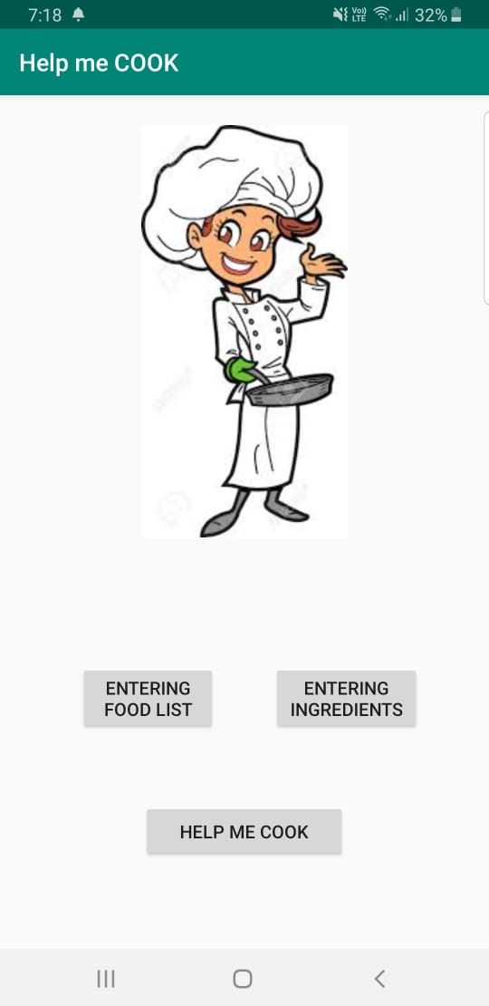

**Fig 1.1 Main Screen of the App**

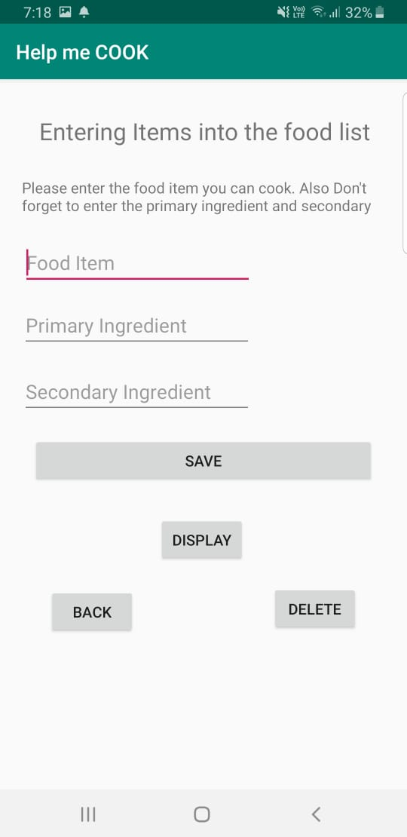

**Fig 1.2 Screen for entering food items**

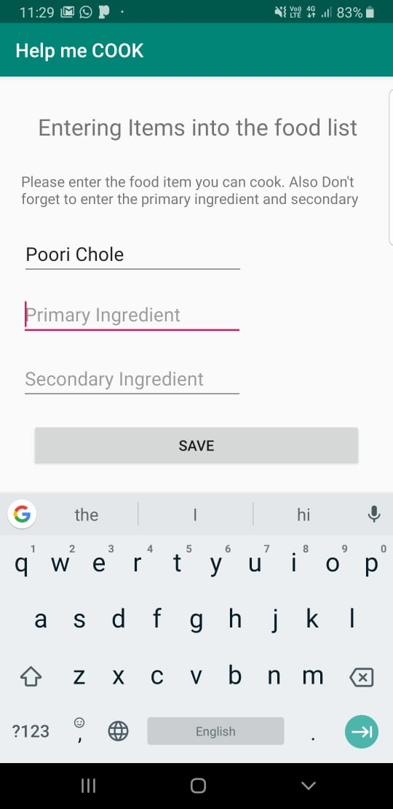

**Fig 1.3 Entering a Food Item**

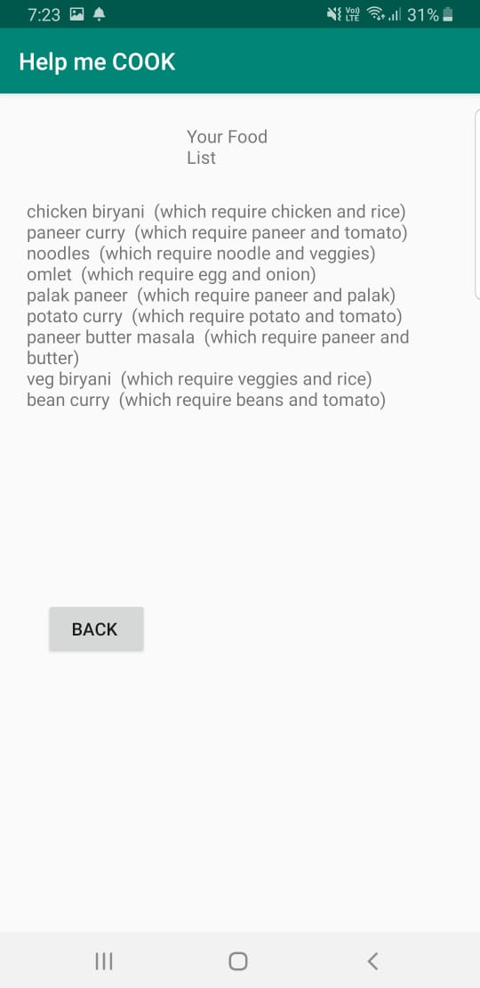

**Fig 1.4 displaying the food List**

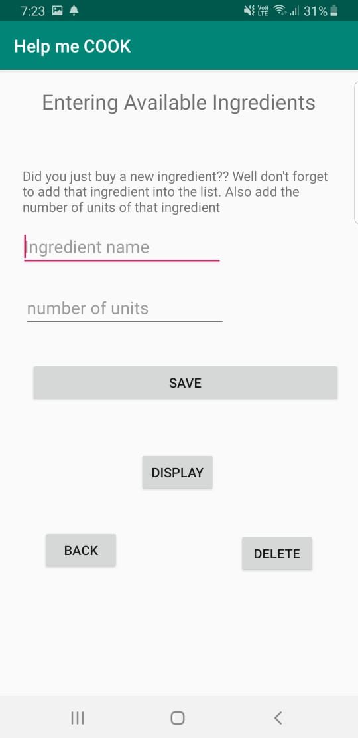

**Fig 1.5 Screen for entering ingredients**

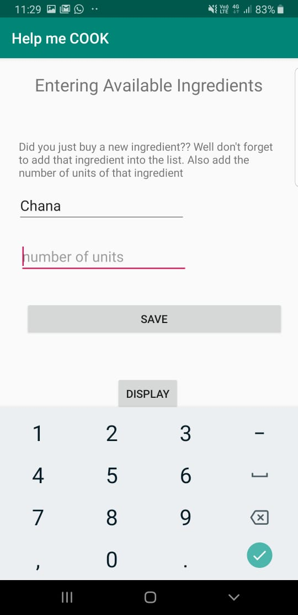

**Fig 1.6 Entering ingredients**

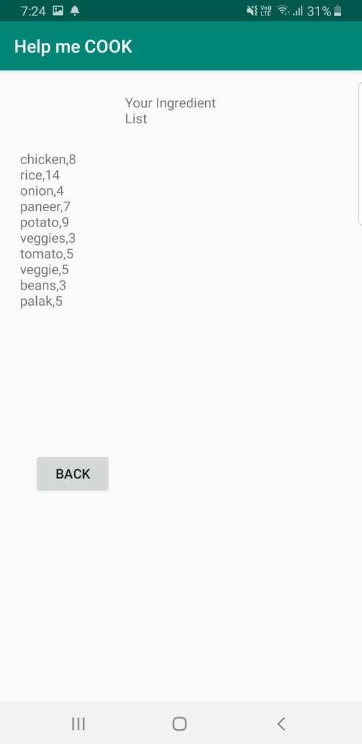

**Fig 1.7 Displaying the available ingredients**

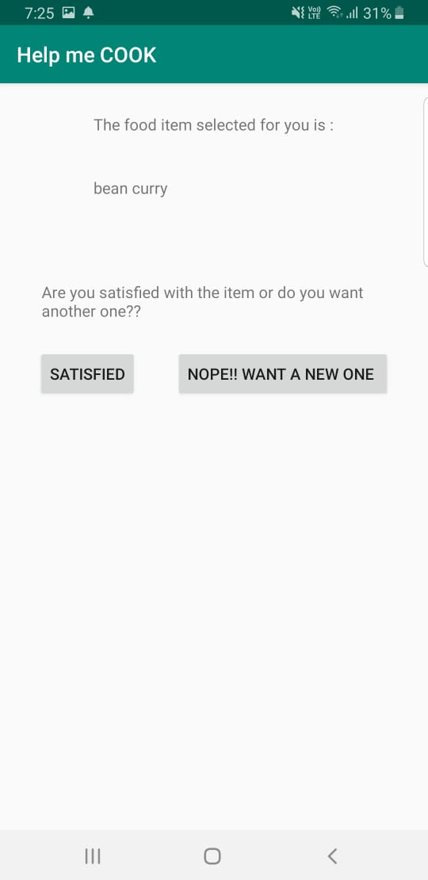

**Fig 1.8 Suggestion of food item**

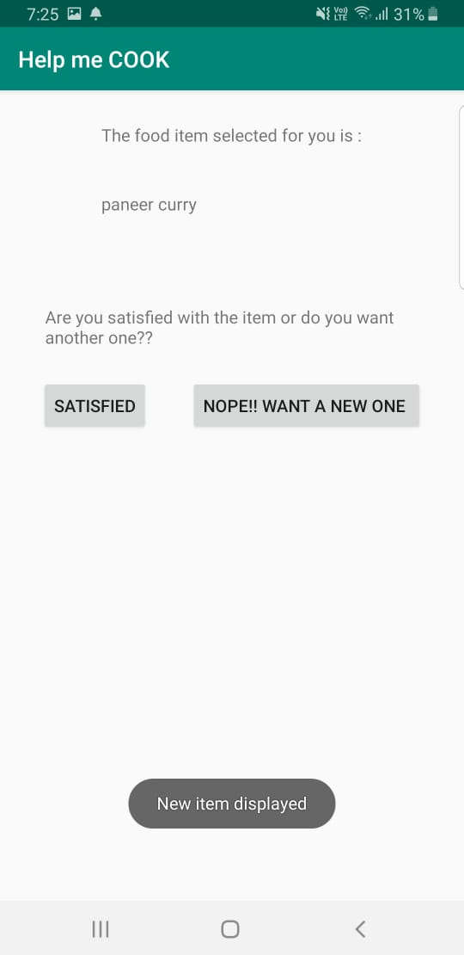

**Fig 1.9 suggesting a new item if not “nope” button is clicked**

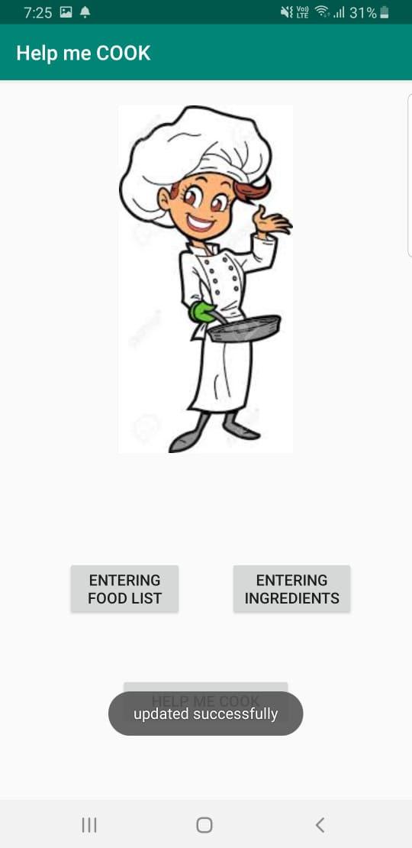

**Fig 1.10 If Satisfied button is clicked**

1. **CONCLUSION**

Thus from the developed application we can automate a simple yet time consuming task i.e., deciding what to cook. This app will provide a fool proof method of deciding what to cook and thus saving us a lot of time and energy. It will also help working women to immediately look up the available ingredients in home and also ask the app to suggest an item to be cooked. It will also help in reducing the irritation caused in many people while deciding the meal to be cooked.

After further enhancing this app we can also manage a lot of tedious tasks like maintaining a shopping list, and also add an efficient backup system in case of information loss.

1. **FUTURE ENHANCEMENTS**

* We are planning to add Google Drive Backup for storing the Food list and Ingredient List online.
* Recipes for various food items can be added.
* History of previously cooked items can be added for future references.
* The user interface can be enhanced for better visibility.
* Notifications can be added which automatically suggest a food item at a predefined time.

1. **REFERENCES**

* Basic information on android -<https://www.elprocus.com/what-is-android-introduction-features-applications/>
* Herbert Schildt, “Input/Output: Exploring java.io”, in The Complete Reference in Java, Seventh Edition , McGraw Hill Education-2007
* Herbert Schildt, “String Tokenizer”, in The Complete Reference in Java, Seventh Edition , McGraw Hill Education-2007
* Reto Meier, “File Handling in Android”, in Professional Android 4 Application Development, Wiley Publications-2012
* File Handling in Android-<http://codetheory.in/android-saving-files-on-internal-and-external-storage/>